Whole Blood Basics: How to maintain a stable sample

Posted by Abdul Ally on May 7, 2015 11:00:00 AM

Like any other fluid or tissue sample, whole blood can be most effectively analyzed when its integrity is maintained throughout collection, processing and storage. But how do you maintain the quality of a whole blood sample when considering long term storage? What happens when a sample is not handled properly?
Whole Blood Basics
Whole blood samples are composed of several basic components: red blood cells, white blood cells, platelets and plasma. In addition, whole blood also contains an abundance of small vesicles (exosomes) containing RNA and proteins that serve as intercellular messengers.
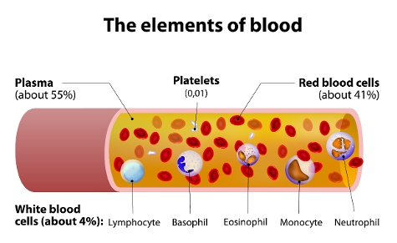
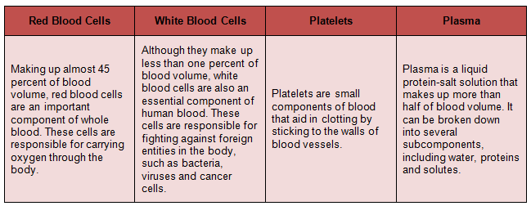
In order to maintain the integrity of a whole blood sample, the collection, processing and storage of blood components must take into consideration their future intended use following storage. This dictates initial blood collection strategies, optimal shipping temperatures, inclusion of additives at time of collection to inhibit degradation of targeted assay components (DNA, RNA, PCR- friendly additives). If guidelines for proper collection, handling and storage are not followed, the integrity of the sample and its use in future analysis will be compromised. Consideration should also be given to the volume of a blood sample that will be needed in targeted assays –this determines the optimal aliquot volume per storage unit.
According to an article published in Transfusion Alternatives in Transfusion Medicine, whole blood samples should be collected, processed and stored in accordance with the following guidelines.
Collection
The desired volume of collected blood samples depends on many factors including the length of a study and the intended uses for these samples, but can range from multiple collections of a little as 1 mL to 450 mL. Samples must be treated with an anticoagulant in order to prevent clotting if the intention is to harvest plasma and blood cells. If desired, stabilizers can be included in the collection device or added to the sample after collection in order to prevent the breakdown of analytes. When serum is desired, blood is normally collected in the absence of anticoagulants.
Some companies are now developing new types of tubes for use in whole blood collection that are designed to stabilize blood and preserve the quality of blood components for longer periods of time. However, these specialized tubes are not always necessary. To determine the best type of collection tube for your study, simply consider your intended analyses. For example, if your study includes the analysis of unstable components, such as RNA, specialized tubes designed to preserve RNA will be required.
Processing
The proper procedure for processing whole blood is heavily dependent upon its intended usage. For example, if intended analyses require platelets, blood must be processed on the day it is collected or after overnight storage. However, if only red cells will be utilized in analyses, whole blood can be stored for up to 72 hours before processing. Finally, if you want to preserve the quality of the plasma, blood must be processed on the day of collection or after no more than 24 hours of storage.
Blood components are typically isolated through centrifugation. After the desired blood components have been isolated, they can be placed into cryovials and stored in liquid nitrogen or mechanical freezers.
Storage
According to the University of California, Los Angeles, blood components should be stored as follows:
  - Red blood cells can be stored for up to 42 days at 1°C - 6°C, depending on the additive. When kept at -65°C or below, red blood cells can be stored for up to 10 years.
  - Platelets can be stored at 20°C - 24°C for up to 5 days with constant agitation.
  - Plasma that is frozen at temperatures of -18°C or below within 8 hours of collection, platelets can be stored for up to 1 year.
However, for long term storage there are different best practices that should be closely followed. A spot of whole blood can be stored on commercially available filter paper at ambient temperatures, but only for a limited number of years and humidity must controlled. When storing plasma and serum for an extended period of time, the recommended temperature is -80°C or below and all cellular components at -150°C or below.

